Mini project
Batch no: DA TE-008
Faculty: Sunitha.v
Student name: M Nithin
Dataset link: https://data.telangana.gov.in/dataset/tgspdcl-ev-charging-stations-consumption-data

Project title: TGSPDCL EV Charging Stations Consumption Analysis Telangana
Data preprocessing using power query
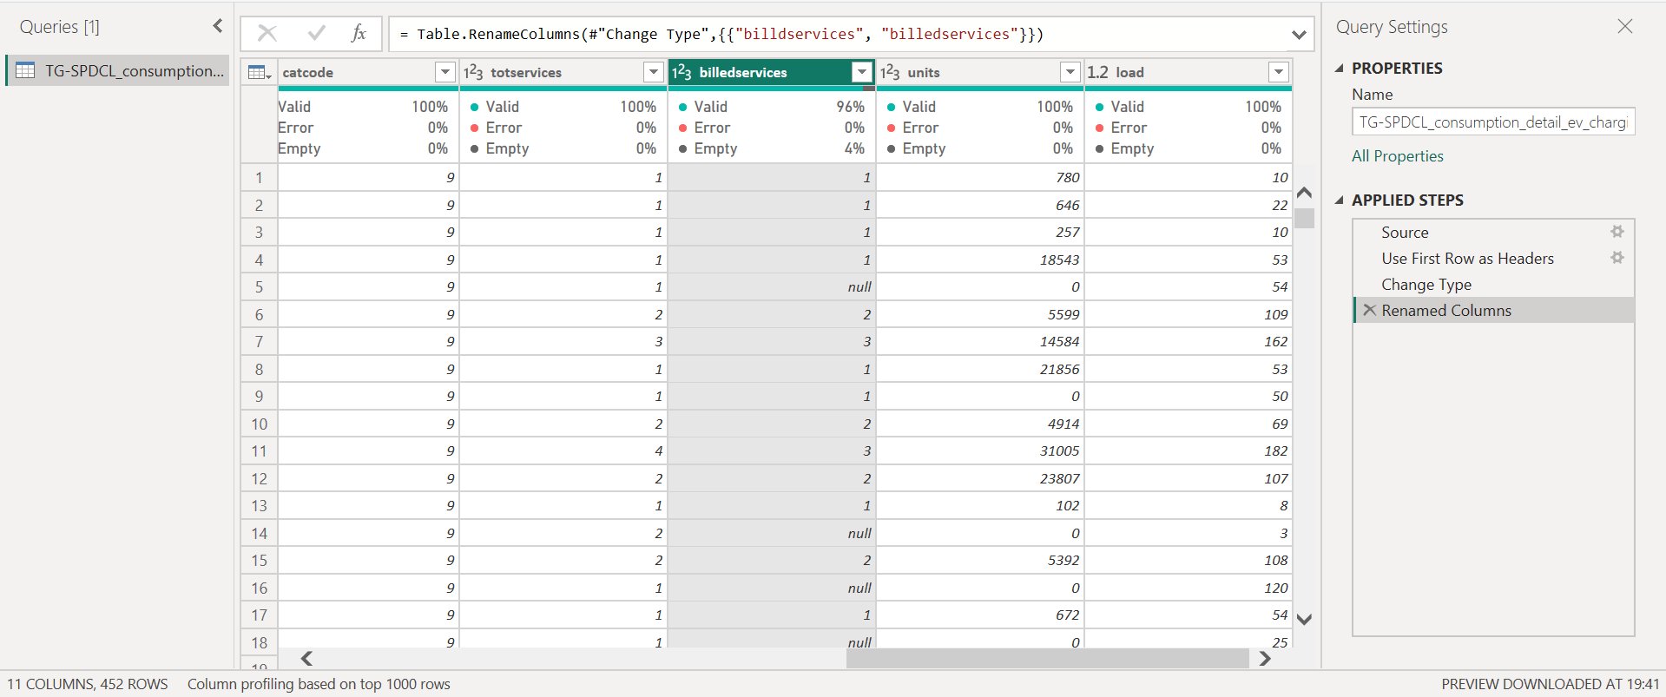
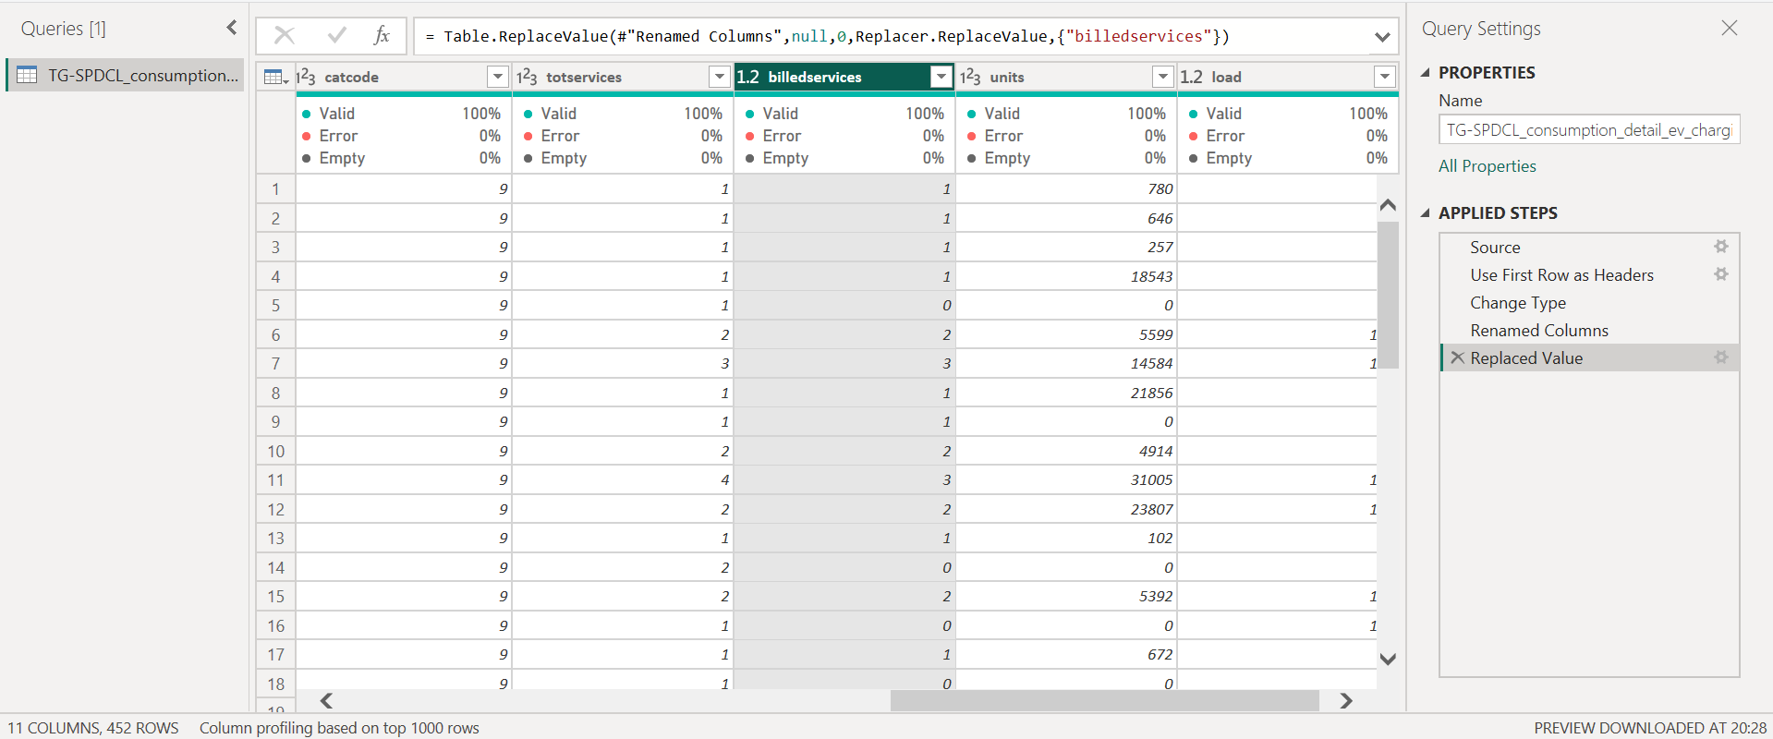

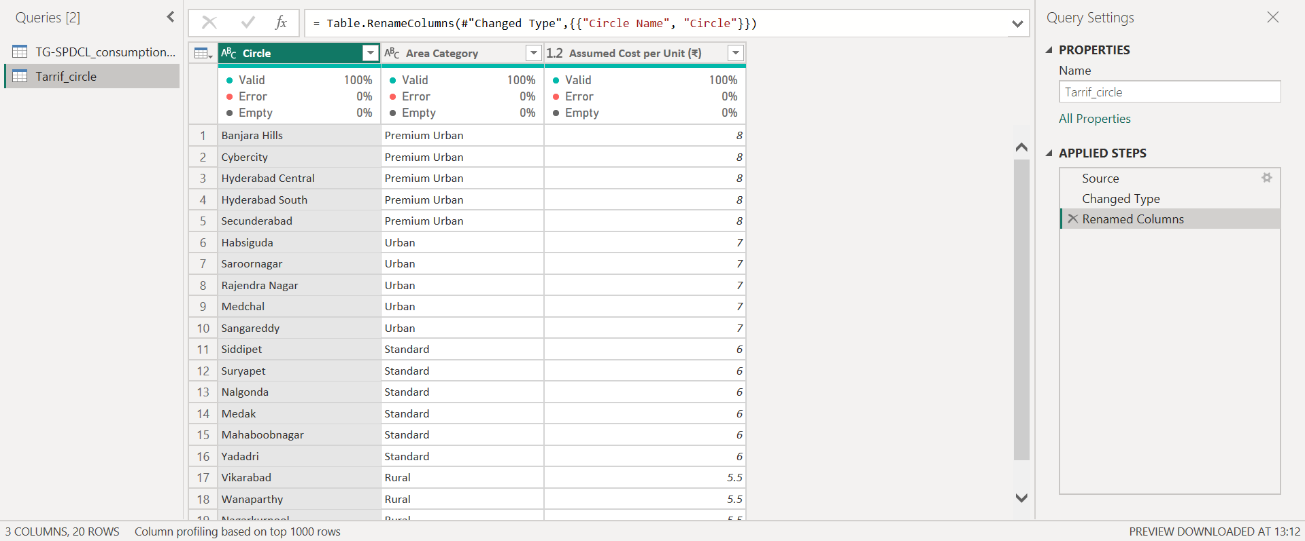
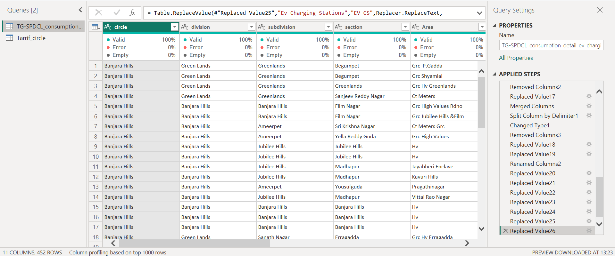
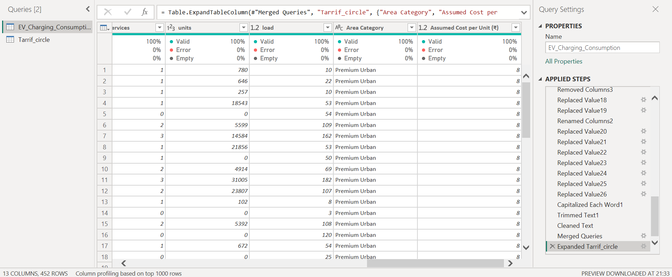
Conclusion:
Data preprocessing was performed using Microsoft Power BI through the Power Query editor to clean and prepare the dataset for analysis. The raw EV charging station data was imported and checked for missing values, duplicate records, and inconsistent formats. Unnecessary columns were removed and column names were standardized for better understanding. Data types such as Units Consumed and Connected Load were converted into proper numeric formats. These transformations ensured the dataset was clean, structured, and ready for dashboard visualization and analysis.

